Day4 Activity2名字:____________________ 日期: ____________________________

Please write down the final price after the discount. You are allowed to use your calculator.
(e.g.七折= ￥original price x .7)

- 裤子打七折 多少钱？ ￥_______。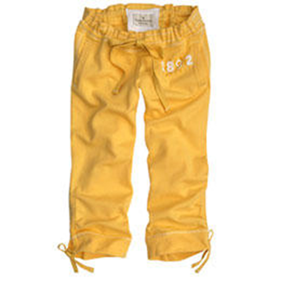
￥200

- 毛衣打五折多少钱？ ￥___________。
￥100

- 鞋子打八折多少钱？ ￥ __________。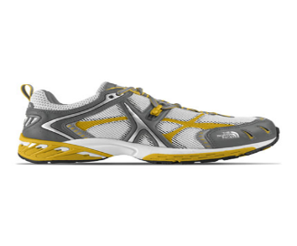
￥500

